Three patterns for microservice architecture

1. API driven
2. Event driven
3. Data streming

Microservices

1. Agile software development
2. Service-oriented architectures
3. API first design
4. Continuous Integration/Continuous Delivery

Twelve-Factor App

No infrastructure to provision or manage

Automatically scaling by unit of consumption

Pay for value billing model

Built-in availability and fault tolerance

Distributed monitoring and auditing

Data consistency

Asynchronous communication

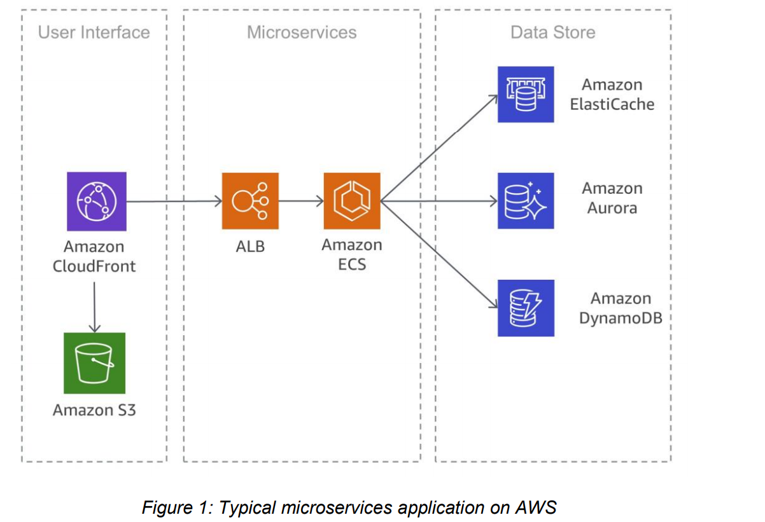

AWS Serverless Application Mode

AWS Cloud map

distributed Saga pattern

event sourcing pattern

Event sourcing is frequently used in conjunction with the CQRS (Command Query Responsibility Segregation) pattern

Amazon Kinesis Data Streams43 serves as the main component of the central event store, which captures application changes as events and persists them on Amazon S3.